

INTEGRATION SERVICE

DETAIL DESIGN – AIG SPECIFIC

© The Marlborough Stirling Canada 2007

Version: 0.2

February 20, 2007

CONTENTS
Revision History iii
1 Introduction 1
1.1 Scope 1
1.2 Audience 1
1.3 References 1
2 Use Cases 2
2.1 Request Mortgage Insurance 2
2.2 Receive Risk Underwriting Response 2
2.3 Request Premium 2
3 Detailed Design 3
3.1 Common Data Interface (CDI) Schema 4
3.1.1 Promoted Property Schema 5
3.2 AIG Schema 5
3.3 Transformation 6
3.4 Configuration Manager 6
3.5 BizTalk Orchestration 9
3.5.1 Exception Handling 12
3.5.2 Message and Variable Types 12
3.6 Security 12
3.7 Service Connector 12
APPENDIX A – CDI Schema 14
APPENDIX B – AIG Schema 29

Revision History

Date | Version | Description | Author | Reviewed By
Dec 05, 2006 | 0.1 | Initial Draft | Nagesh Chawla
Feb 20, 2007 | 0.2 | Modified config details | Nagesh Chawla

Introduction

This document provides a more detailed archiectural design of major components of the high level architecture envisioned for the Integration Service. For the first phase of the Integration Service development, this detailed design will focus on the AIG specific requirements and consumption of AIG published service.

The high level architectural components as specified in the “Integration Service Solution Architecture” document are:
- Common Data Interface (input schema)
- AIG Schema
- Transformation mapping
- Configuration Manager
- BizTalk Orchestration
- Authentication
- Service Connector

Scope
The current scope of this document focuses on integrating AIG service. Components with more generic nature will not be discussed in this document.

Audience
The audiences of this document are:
Systems Analysts: MorWEB, Omiga and Optimus system analysts.
Reviewers: Product management.

References
  - Integration Service High Level Solution Architecture
  - AIG UG Technical Interface Document - 2006

Use Cases

The current implementation of the service supports the following use cases:

  - Request mortgage insurance
  - Receive risk underwriting response
  - Request premium

Request Mortgage Insurance
To request mortgage insurance, MSC applications (MorWEB and OmigaASP) initiate a request to AIG published service interface with detailed information regarding a deal. Once received, the AIG service processes the request and responds with either “approve” status along with insurance information or “risk underwriting” indication. The response from AIG service is then sent back to the request originating application.

Another extension of this use case is that when the response from AIG service refers to “risk underwriting”, then the user can post the same request (with difference status indicated in AIG schema) to pull the response from AIG service for the original request.

Receive Risk Underwriting Response
When the request for mortgage insurance results in “risks underwriting” status, the AIG service will invoke a response to the original request when the underwriting process is complete. The AIG servcie will connect to the Integration Service and send the response. Techcnically this a request for the Integration Service.

Request Premium
The MSC application initiates a request to the AIG pusblished service with loan specific information. The AIG service will responsd with premium related information.

Detailed Design

This section presents detailed design of major architectural components to implement the use cases. The high level architecture discussed in the architectural document is presented in the figure below:

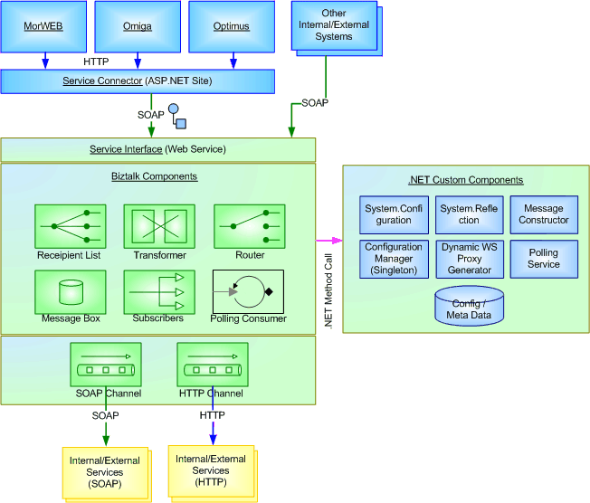

Figure 1: High Level Architecture for Integration Service

The functional activity of overall messaging mechanism involved in accomplishing the use cases is illustrated by the following figure. The activities are:

- A user invokes a request from the MorWEB application.
- The application compiles necessary data required to process the request in CDI format and posts to the Service Connector using XMLHTTP protocol.
- Service Connector loads XML data into CDI schema object, which is the input type for the service and posts the object to the service.
- The service retrieves configuration data, determines the recipient of the message, transforms the message and sends to AIG specific web service interface using SOAP adapter.
- The recipient, in this case AIG service, processes the request and returns a response.
- The Integration Service returns the response to the user via the Service Connector and MorWEB for further processing.
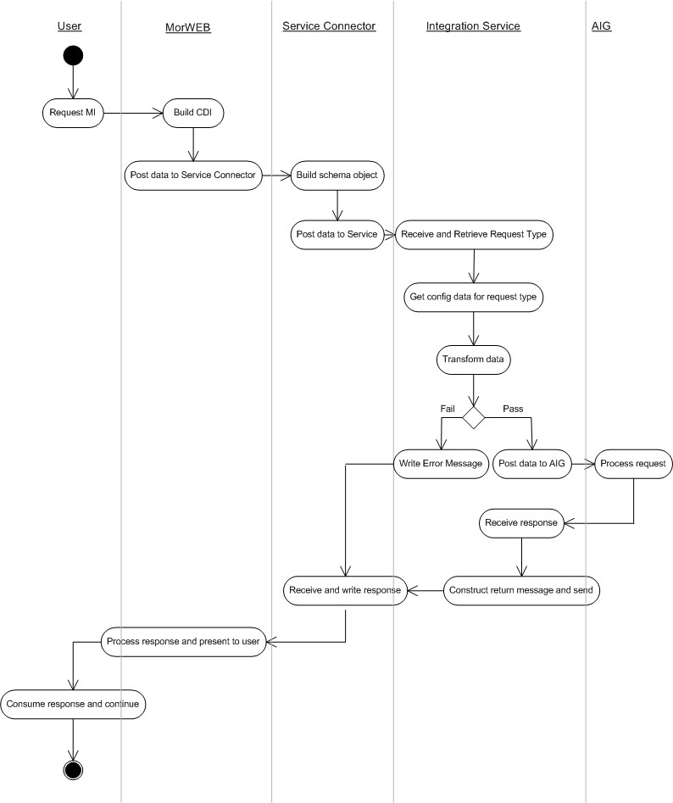
Figure 2: Functional Activity of Overall Messaging

The specific details of the Service Connector and major components of the Integration Service involved in achieving the above activity are discussed in the following sections.

Common Data Interface (CDI) Schema
CDI is a unified data interface across all request types for the Integration Service. The input to the service should conform to this schema, the first draft of which is provided in the Appendix A. The goal of the CDI is to facilitate a common data structure across all systems, which could evolve as an industry standard language specification, at least within MSC.

The major sections of CDI are as follows:
- Clipboard
- Context
- Request
  - Comment
  - Errors
- Application Data

Clipboard is a root element in the CDI and contains the namespace http://mscanada.com

Context describes the context within which the domain data instance is created and used. This section specifies application name, language, date time and user id etc.

Request describes what type of request is being made by the system. This section amongst other data contains request id, a guid value to identify the request uniquely and service type, a handle that may be mapped to configuration data implemented separately in a central store. The request id will also enable us to correlate an asynchronous response to the original request at later stage.

Comment contains any comments regarding request or response.

Errors contain a collection of error nodes to communicate any errors that are encountered.

Application Data contains a cross section of domain data. IN case of a response this node can also be mapped to response data and return to the calling application.

The CDI schema needs to be reviewed and developed further during development phase.

Promoted Property Schema
Promoted properties enable BizTalk Server components to access key data elements of a schema. By promoting key elements of a schema, the BizTalk components can access incoming message data without even loading it into the memory. The key data elements help navigate through BizTalk orchestration and routing. Further, the promoted properties can be used in filter conditions when multiple physical send ports are configured.

The data elements that will be promoted from the CDI schema are serviceType, source and provider attributes of request node. The provider and serviceType values should match section name and serviceType element in the configuration file. This will allow easy retrieval of configuration data and use the data in orchestration. The orchestration will retrieve the message related configuration data using Configuration Service, which is discussed later in this document. Further details regarding promoting these attributes are discussed in the Transformation section

AIG Schema
AIG provided their schema. Appendix B provides this schema for reference purposes.

Transformation
When integrating an external system, usually data is sent in a format which is required by the external system. In this partuclar implementation the requesting application (MorWSEB) sends data in CDI format and the recipient of the request, AIG expects data in AIG schema compliant format. Therefore the data needs to be transformed from CDI to AIG schema. BizTalk provides schema mapping functionality.

To achieve this transformation:
- Create a project named “Schemas” within MSC namespace using BizTalk project template. Keep all schemas for the Integration Service within this project.
- Open CDI schema.
- Promote serviceType, provider and source attributes of the request node using Quick Promotion option.
- Create a BizTalk map (.btm file) using map editor in BizTalk from CDI schema as the source and AIG schema as the destination. Name it CDI_AIG.btm. The mapping details will be presented in separate spread sheets.
- Create a strong name key file. All components must be signed and installed in GAC, to be used by BizTalk runtime.
- Change project properties to include the strong name key file information.
- Compile the project.
- Install the project in GAC using gacutil.
- Once installed in GAC, copy the publicKeyToken of the assembly and update “requestMapType” attribute of serviceType element in the configuration file. This will allow orchestration ot dynamically load the mapping assembly at runtime.

Configuration Manager
The Integrationn Service orchestration depends up on some basic configuration data that instructs message semantics. The following table shows the configuration data needed to forward a message to a destination.

<?xml version="1.0" encoding="utf-8"?>
<configuration>
<configSections>
<section name="AIG" type="MSC.ConfigurationService.messageConfig,MSC.ConfigurationService"/>
<section name="MorWEB" type="MSC.ConfigurationService.messageConfig,MSC.ConfigurationService"/>
<section name="GMAC" type="MSC.ConfigurationService.messageConfig,MSC.ConfigurationService"/>
</configSections>
<AIG description="" type="provider">
<serviceTypeList>
<serviceType name="RequestMI" direction="outbound" aggregateResponse="false">
<recipientList>
<recipient name="" url="" userId="" password="" protocol="" assembly=""
operation="" operationType="sync|async"
recipientDomain="internal|external" requestMapType="" responseMapType="" />
</recipientList>
</serviceType>
<serviceType name="RequestPremium" direction="outbound" aggregateResponse="false">
<recipientList>
<recipient name="" url="" userId="" password="" protocol="" assembly=""
operation="" operationType="sync|async"
recipientDomain="internal|external" requestMapType="" responseMapType="" />
</recipientList>
</serviceType>
</serviceTypeList>
</AIG>
<MorWEB>
<serviceTypeList>
<serviceType name="ReceiveRiskUW" direction="inbound" aggregateResponse="false">
<recipientList>
<recipient name="" url="" userId="" password="" protocol="" assembly=""
operation="" operationType="sync|async"
recipientDomain="internal|external" requestMapType="" responseMapType="" />
</recipientList>
</serviceType>
</serviceTypeList>
</MorWEB>
<GMAC>
<serviceTypeList>
<serviceType name="ReceiveRiskUW" direction="inbound" aggregateResponse="false">
<recipientList>
<recipient name="" url="" userId="" password="" protocol="" assembly=""
operation="" operationType="sync|async"
recipientDomain="internal|external" requestMapType="" responseMapType="" />
</recipientList>
</serviceType>
</serviceTypeList>
</GMAC>
</configuration>

To facilitate mangement of this configuration data, implementation will leverage .NET 2.0 System classes within Configuration namespace. It will use XML file storage provider to specify the config data and the XML Serializer for data transformation. Implmentation of this configurtation management consists of custom and derived classes that make up a Configuration Service. The goal is to evolve this re-usable configutration service for all MSC products eventually.

The following class diagram shows the initial implementation of the Configuration Service.

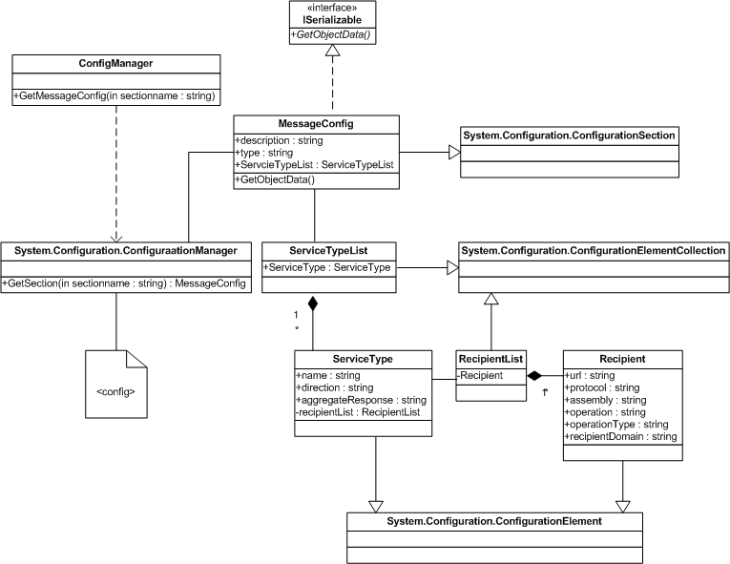

Figure 3: Configuration Service Static View

.NET 2.0 Configuration namespace provides ConfigurationSection class that handles each section specified within the configuration file. The custom class MessageConfig is inherited from the ConfigurationSection class and provides deserialized instance of section data. The MessageConfig class uses ServiceTypeList class that is inherited from ConfigurationElementCollection class. This class represents all services or service types implemented by a given provider. From the Integration Service view point, a service type may represent other processes that may have to be completed for the current message or request by calling other services or processes, which are represented by a list of recipients. These recipients are listed by RecipientList class that is inherited from ConfigurationElementCollection. RecipientList class represents collections of recipients specified for a given message. The RecipientList class uses Recipient that is inherited from ConfigurationElement class and represents each recipient’s meta data. Note that the MessageCOnfig class needs to implement ISerializable interfacae in order to serialize between CLR and BizTalk runtime processes.

The client object that needs to consume configuration data invokes ConfigManager and calls GetMessageConfig method. This class uses ConfigurationManager class, which implements complete XML serialization plumbing, to retrieve configuration data and return MessageConfig class.

The specification of GetMessageConfig method of ConfigManager is as follows:
- Declare a variable of MessageConfig class type.
- Call ConfigurationManager’s GetSection method while passing section name.

The Configuration Service is extensible. As long as the implementation of MessageConfig conforms to the schema of message section (XML elements and attributes), any number of sections can be specified and the Configuration Service can be used to retrieve that data.

BizTalk Orchestration
BizTalk orcehstration is the core of the Integration Service. The orchestration contains BizTalk components such as Expressions, Transformers, logical Ports, etc. The following sequence diagram illustrates how a message received by the Integration Service is processed.

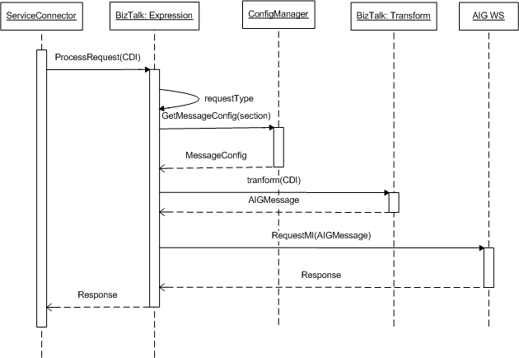

Figure 4: Messaging Mechnism in the Integration Service

The BizTalk orchestration will be published as a web service. This is further discusssed in this section below. Once the message is received by the service via web service interface, logic implemented within an Expression shape determines the provider for the request and service type. This is done by simply reading the values of promoted properties into a variable. Based on the service type, configuation data related to this request is retrieved using ConfigManager, which returns MessageConfig object. The object is captured into a variable declared within the orchestration for further consumption. The configuration data contains appropriate assembly information to be used to perform the transformation. Using this information, BizTalk tranformation is invoked to construct a message in AIG request schema. This message is then sent to AIG published web service via logical port. When response is received from the AIG web service, it is forwarded back to the Service Connector.

The following diagram illsutrates a sample implementation of BizTalk orchestration for the AIG specific use cases. This may be changed as required during actual development phase and may further be changed to accommodate more generic functionality during next phase of development to implement functions such as polling and persistent database. The intent of this diagram here is to facilitate design discussion around some of the key elements of the orchestration and to provide visual assistance in understanding the discussion.

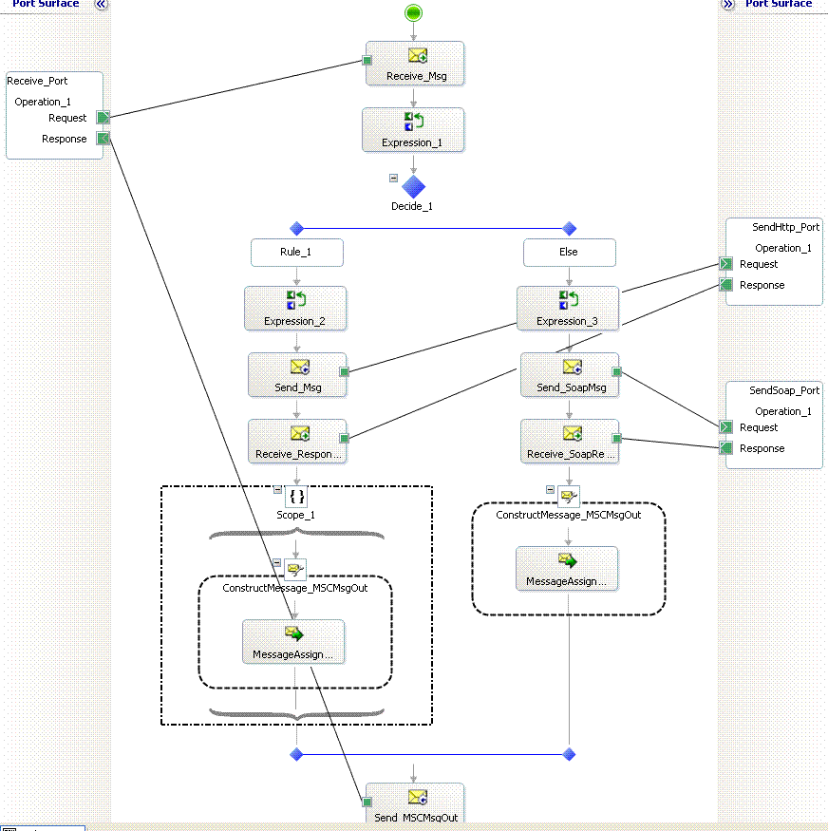
Figure 5: Sample Orchestration for AIG Use Cases

Receive_Port on the left hand side is a logical port and is an entry point for the orchestration. This logical port is mapped to a physical port at deployment time and attached to a specific adapter type such as HTTP, SOAP etc. In the AIG implementation, the orchestration will be published as a web service. Therefore the Receive_Port will be mapped to a SOAP adapter and web service URL using BizTalk Explorer. This port is a request and response type as the AIG call is synchronous.

Message received by the port is passed to Receive_Msg shape. The message type this shape receives conforms to CDI schema. Therefore message variable of type CDI schema is declared and assigned it to the shape. The message is then passed to an Expression shape where logic to retrieve configuration data is implemetned, as shown in the sequence diagram. Once the message configuration is determined, messgae is transformed to the target schema using BizTalk transformation map. This is achievedd using .NET reflection to load BizTalk map assembly and transform.

A decision shape helps route the transformed message based on a tagret protocol information. In this initial implemetnation, the orchestration will support HTTP and SOAP protocols. Within each decision branch, another expression shape is used to assign routing protocol specific information to the message dynamically, such as assembly of web service proxy, method name etc. A send shape, Send_SoapMsg, sends message to SendSoap_Port logical port. The logical port is a request-response type. This logical port is directly bound BizTalk message box. This enables publish-subscribe mechanism. All out going messages are published to BizTalk message box. At deployment time, multiple physical send ports (subscribers) can be implemetned to subscribe messages from message box and send them to their recipients. This is achieved by implementing filter conditions on the send port using promoted properties within BizTalk Explorer. The following diagram illustrates this mechanism:

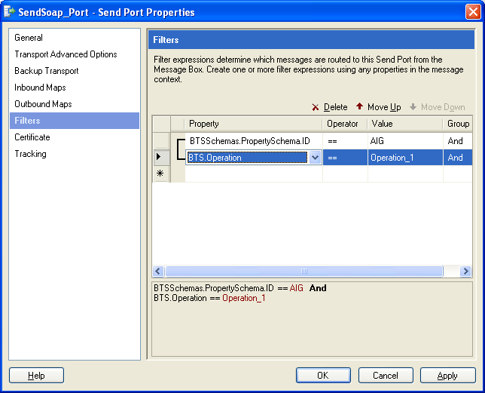

Figure 6: Filter Conditions on Physical Send Port in BizTalk Explorer

The response is received by another receive shape and is passed to a Message Constructor to construct response message going back to the Service Connector.

Exception Handling
All exceptionos are caught using an atomic scope in BizTalk. The CDI schema contains “error” node collection. When an exception occurs, the incoming message in CDI format is updated with exception details and sent back to caller. The calling application is responsible for reacting to the exception, correcting the request information and re-sending the request if needed.

To implement exception handling:

- Drop an atomic scope shape in the orchestration.
- Create an object of type System.Exception in the orchestration.
- Catch the exception details.
- Update CDI input message.
- Return.

Message and Variable Types
The following message and variable types are required to implment AIG specific orchestration:

Message | Description
MSCMessage | Represents incoming message. The message type is of CDI schema.
TargetMsg | Represents outgoing message. The message type os of AIG schema.
ResponseMsg | Represents response from external system. The message type is of System.Xml.XmlDocument.
MSCRespMsg | Represents response from the integration service. The message type is of System.Xml.XmlDocument.

Variable | Description
ID | Represents property schema attribute. Type System.String.
mapName | Represents map to be used for transformation. Type System.String.
mapType | Represents map assembly. Type System.Type.
MsgConfig | Represents MessageConfig configuration object. Type MSC.ConfigurationService.MessageConfig

Security
The Integration Service will be secured using two layer security approach; one transport layer security using SSL and second message level security using WS-Security protocol.
<<Details pending>>

Service Connector
The Service Connector is a bridge between MSC applications (MorWEB, Omiga and Optimus) and the Integration Service. This Connector is intended to minimize integration effort required on the application side while eliminating the need to incorporate tools like SOAP Toolkit to consume the service.

The initial implementation of the Service Connector is an ASP.NET application with one page and a method in the page. The specification of the page and the method is as follows:

Page:
  - Implement default.aspx page in a project.
  - Add Web Reference to consume Integration Service web service interface.
  - Do not implement any UI elements and remove <Form> tag from the design view.
  - After the Page directive, call a method PostMessage implemented in the page code behind file while passing HTTP Request object and write response back.
<% Response.Write(PostMessage(Request)); %>

PostMessage Method:
  - Implement a method PostMessage in code behind file
  - The method receives HTTP Request object as input.
  - The Request object contains the XML string that conforms to CDI discussed in the earlier section.
  - Note that the Integration Service interface accepts XML data that conforms to the CDI schema. Create a variable of type web service interface input parameter schema.
  - Deserialize the input XML stream to the above web service interface input parameter schema type.
  - Call web service interface while passing the deserialized data instance.
  - Return outerxml of the response XML object.

APPENDIX A – CDI Schema
<?xml version="1.0" encoding="utf-16" ?>
- <xs:schema xmlns:b="http://schemas.microsoft.com/BizTalk/2003" attributeFormDefault="unqualified" elementFormDefault="qualified" targetNamespace="http://mscanada.com" xmlns:xs="http://www.w3.org/2001/XMLSchema">
- <xs:element name="clipboard">
- <xs:complexType>
- <xs:sequence>
- <xs:element name="context">
- <xs:complexType>
<xs:attribute name="applicationName" type="xs:string" use="required" />
<xs:attribute name="sessionId" type="xs:string" use="required" />
<xs:attribute name="userid" type="xs:string" use="required" />
<xs:attribute name="language" type="xs:string" use="required" />
<xs:attribute name="dateTime" type="xs:string" use="required" />
</xs:complexType>
</xs:element>
- <xs:element name="request">
- <xs:complexType>
- <xs:sequence>
<xs:element name="comment" type="xs:anyType" />
- <xs:element name="errors">
- <xs:complexType>
- <xs:sequence>
- <xs:element name="error">
- <xs:complexType>
<xs:attribute name="code" type="xs:string" use="required" />
<xs:attribute name="message" type="xs:string" use="required" />
</xs:complexType>
</xs:element>
</xs:sequence>
</xs:complexType>
</xs:element>
</xs:sequence>
<xs:attribute name="requestId" type="xs:string" use="required" />
<xs:attribute name="serviceType" type="xs:string" use="required" />
<xs:attribute name="source" type="xs:string" use="required" />
<xs:attribute name="provider" type="xs:string" use="required" />
</xs:complexType>
</xs:element>
<xs:element minOccurs="0" maxOccurs="1" name="applicationData" type="xs:anyType" />
</xs:sequence>
</xs:complexType>
</xs:element>
</xs:schema>

Note that the applicationData is of anyType. This is to accommodate different input types while providing a unified messag type from the Integration service view point.

APPENDIX B – AIG Schema
<?xml version="1.0" encoding="UTF-8"?>
<wsdl:definitions targetNamespace="http://www.aigug.ca/services/b2borchestrationservice" xmlns:apachesoap="http://xml.apache.org/xml-soap" xmlns:impl="http://www.aigug.ca/services/b2borchestrationservice" xmlns:intf="http://www.aigug.ca/services/b2borchestrationservice" xmlns:tns1="http://www.ugcorp.com/business/common" xmlns:wsdl="http://schemas.xmlsoap.org/wsdl/" xmlns:wsdlsoap="http://schemas.xmlsoap.org/wsdl/soap/" xmlns:xsd="http://www.w3.org/2001/XMLSchema">
<!--WSDL created by Apache Axis version: 1.3
Built on Oct 05, 2005 (05:23:37 EDT)-->
<wsdl:types>
<schema elementFormDefault="qualified" targetNamespace="http://www.ugcorp.com/business/common" xmlns="http://www.w3.org/2001/XMLSchema">
<import namespace="http://www.aigug.ca/services/b2borchestrationservice"/>
<import namespace="http://xml.apache.org/xml-soap"/>
<complexType name="AssetData">
<sequence>
<element name="assetAmount" type="xsd:double"/>
<element name="assetNumber" type="xsd:long"/>
<element name="assetTypeCode" type="xsd:int"/>
<element name="assetTypeDesc" nillable="true" type="xsd:string"/>
<element name="borrower" nillable="true" type="tns1:BorrowerData"/>
<element name="dealNumber" type="xsd:long"/>
<element name="percentInNetworth" type="xsd:double"/>
<element name="ugLoanNumber" type="xsd:long"/>
</sequence>
</complexType>
<complexType name="AddressData">
<sequence>
<element name="addressId" type="xsd:long"/>
<element name="addressline1" nillable="true" type="xsd:string"/>
<element name="addressline2" nillable="true" type="xsd:string"/>
<element name="apartmentNumber" nillable="true" type="xsd:string"/>
<element name="city" nillable="true" type="xsd:string"/>
<element name="countryCode" type="xsd:int"/>
<element name="dirty" type="xsd:boolean"/>
<element name="legalName1" nillable="true" type="xsd:string"/>
<element name="legalName2" nillable="true" type="xsd:string"/>
<element name="legalName3" nillable="true" type="xsd:string"/>
<element name="municipalityName" nillable="true" type="xsd:string"/>
<element name="postalCode" nillable="true" type="xsd:string"/>
<element name="province" type="xsd:int"/>
<element name="provinceForUI" nillable="true" type="xsd:string"/>
<element name="state" nillable="true" type="xsd:string"/>
<element name="streetDirectionCode" type="xsd:int"/>
<element name="streetName" nillable="true" type="xsd:string"/>
<element name="streetNumber" nillable="true" type="xsd:string"/>
<element name="streetTypeCode" type="xsd:int"/>
</sequence>
</complexType>
<complexType name="BorrowerAddressData">
<sequence>
<element name="address" nillable="true" type="tns1:AddressData"/>
<element name="addressId" type="xsd:long"/>
<element name="borrower" nillable="true" type="tns1:BorrowerData"/>
<element name="bwAddressNumber" type="xsd:long"/>
<element name="currentAddressOwnershipCode" type="xsd:int"/>
<element name="dealNumber" type="xsd:long"/>
<element name="numberOfMonthsAtAddress" type="xsd:int"/>
<element name="sameAsFirstBorrower" type="xsd:boolean"/>
<element name="typeCode" type="xsd:int"/>
<element name="ugLoanNumber" type="xsd:long"/>
</sequence>
</complexType>
<complexType name="BorrowerCreditReferenceData">
<sequence>
<element name="borrower" nillable="true" type="tns1:BorrowerData"/>
<element name="creditRefNumber" type="xsd:long"/>
<element name="creditReferenceDesc" nillable="true" type="xsd:string"/>
<element name="creditReferenceTypeCode" type="xsd:int"/>
<element name="currentBalanceAmount" type="xsd:double"/>
<element name="dealNumber" type="xsd:long"/>
<element name="institutionName" nillable="true" type="xsd:string"/>
<element name="timeWithReference" type="xsd:int"/>
<element name="ugLoanNumber" type="xsd:long"/>
</sequence>
</complexType>
<complexType name="IdentityData">
<sequence>
<element name="dirty" type="xsd:boolean"/>
<element name="firstName" nillable="true" type="xsd:string"/>
<element name="identityNumber" type="xsd:long"/>
<element name="lastName" nillable="true" type="xsd:string"/>
<element name="middleName" nillable="true" type="xsd:string"/>
<element name="secondLastName" nillable="true" type="xsd:string"/>
<element name="suffix" type="xsd:int"/>
<element name="title" type="xsd:int"/>
</sequence>
</complexType>
<complexType name="PhoneContactData">
<sequence>
<element name="areaCode" nillable="true" type="xsd:string"/>
<element name="countryCode" nillable="true" type="xsd:string"/>
<element name="empty" type="xsd:boolean"/>
<element name="exchange" nillable="true" type="xsd:string"/>
<element name="localCode" nillable="true" type="xsd:string"/>
<element name="phoneExtnNumber" nillable="true" type="xsd:string"/>
<element name="phoneNumberId" type="xsd:long"/>
</sequence>
</complexType>
<complexType name="CreditData">
<sequence>
<element name="borrower" nillable="true" type="tns1:BorrowerData"/>
<element name="creditBureauNameCode" type="xsd:int"/>
<element name="creditDataId" type="xsd:long"/>
<element name="creditRecordDate" nillable="true" type="xsd:dateTime"/>
<element name="creditVendorDataId" type="xsd:long"/>
<element name="dealNumber" type="xsd:long"/>
<element name="errorStatusCode" type="xsd:int"/>
<element name="score" type="xsd:int"/>
<element name="scoreTypeCode" type="xsd:int"/>
<element name="scoringCompany" nillable="true" type="xsd:string"/>
<element name="ugLoanNumber" type="xsd:long"/>
</sequence>
</complexType>
<complexType name="EmploymentHistoryData">
<sequence>
<element name="borrower" nillable="true" type="tns1:BorrowerData"/>
<element name="dealNumber" type="xsd:long"/>
<element name="empHistNumber" type="xsd:long"/>
<element name="employerName" nillable="true" type="xsd:string"/>
<element name="employmentHistoryStatusCode" type="xsd:int"/>
<element name="employmentHistoryTypeCode" type="xsd:int"/>
<element name="incomeSequenceNumber" type="xsd:int"/>
<element name="industrySectorCode" type="xsd:int"/>
<element name="jobTitleCode" type="xsd:int"/>
<element name="languagePreferenceCode" type="xsd:int"/>
<element name="monthsOfServiceCount" type="xsd:int"/>
<element name="occupationCode" type="xsd:int"/>
<element name="preferredDeliveryMethodCode" type="xsd:int"/>
<element name="salutationCode" type="xsd:int"/>
<element name="ugLoanNumber" type="xsd:long"/>
<element name="workAddress" nillable="true" type="tns1:AddressData"/>
<element name="workPhoneNumber" nillable="true" type="tns1:PhoneContactData"/>
</sequence>
</complexType>
<complexType name="IncomeData">
<sequence>
<element name="borrower" nillable="true" type="tns1:BorrowerData"/>
<element name="dealNumber" type="xsd:long"/>
<element name="incomeAmount" type="xsd:double"/>
<element name="incomeDescription" nillable="true" type="xsd:string"/>
<element name="incomeNumber" type="xsd:long"/>
<element name="incomePeriodCode" type="xsd:int"/>
<element name="incomeTypeCode" type="xsd:int"/>
<element name="monthlyIncomeAmount" type="xsd:double"/>
<element name="percentIncludedInGDS" type="xsd:int"/>
<element name="percentIncludedInTDS" type="xsd:int"/>
<element name="ugLoanNumber" type="xsd:long"/>
</sequence>
</complexType>
<complexType name="LiabilityData">
<sequence>
<element name="borrower" nillable="true" type="tns1:BorrowerData"/>
<element name="dealNumber" type="xsd:long"/>
<element name="liabSeqNumber" type="xsd:long"/>
<element name="liabilityAmount" type="xsd:double"/>
<element name="liabilityDescription" nillable="true" type="xsd:string"/>
<element name="liabilityPaymentCode" type="xsd:int"/>
<element name="liabilityPayoffTypeCode" type="xsd:int"/>
<element name="liabilityTypeCode" type="xsd:int"/>
<element name="monthlyLiabilityAmount" type="xsd:double"/>
<element name="percentIncludedInGDS" type="xsd:int"/>
<element name="percentIncludedInTDS" type="xsd:int"/>
<element name="ugLoanNumber" type="xsd:long"/>
</sequence>
</complexType>
<complexType name="BorrowerData">
<sequence>
<element name="age" type="xsd:int"/>
<element name="assetInfo" nillable="true" type="impl:ArrayOf_tns1_AssetData"/>
<element name="assetInfos" nillable="true" type="impl:ArrayOf_tns1_AssetData"/>
<element name="bankAccountIndicator" type="xsd:boolean"/>
<element name="bankruptStatusCode" type="xsd:int"/>
<element name="borrowerAddresses" nillable="true" type="impl:ArrayOf_tns1_BorrowerAddressData"/>
<element name="borrowerBirthDate" nillable="true" type="xsd:dateTime"/>
<element name="borrowerCreditReferences" nillable="true" type="impl:ArrayOf_tns1_BorrowerCreditReferenceData"/>
<element name="borrowerGeneralStatusIdentifier" type="xsd:int"/>
<element name="borrowerIdentity" nillable="true" type="tns1:IdentityData"/>
<element name="borrowerNumber" type="xsd:long"/>
<element name="borrowerPhoneNo" nillable="true" type="tns1:PhoneContactData"/>
<element name="borrowerTypeCode" type="xsd:int"/>
<element name="citizenshipTypeCode" type="xsd:int"/>
<element name="clientReferenceNumber" type="xsd:double"/>
<element name="creditDatas" nillable="true" type="impl:ArrayOf_tns1_CreditData"/>
<element name="dealNumber" type="xsd:long"/>
<element name="educationalLevelCode" type="xsd:int"/>
<element name="employmentHistories" nillable="true" type="impl:ArrayOf_tns1_EmploymentHistoryData"/>
<element name="employmentTypeCode" type="xsd:int"/>
<element name="existingClientIndicator" type="xsd:boolean"/>
<element name="firstTimeBuyerIndicator" type="xsd:boolean"/>
<element name="genderCode" type="xsd:int"/>
<element name="grossDebtServices" type="xsd:double"/>
<element name="grossDebtServicesForThreeYears" type="xsd:double"/>
<element name="guarantorOtherLoansIndicator" type="xsd:boolean"/>
<element name="identificationCheckDigit" type="xsd:int"/>
<element name="identificationNumber" type="xsd:int"/>
<element name="incomeInfos" nillable="true" type="impl:ArrayOf_tns1_IncomeData"/>
<element name="languagePreferenceCode" type="xsd:int"/>
<element name="liabilityInfos" nillable="true" type="impl:ArrayOf_tns1_LiabilityData"/>
<element name="loan" nillable="true" type="tns1:LoanData"/>
<element name="maritalStatusCode" type="xsd:int"/>
<element name="monthsAsLenderCustomer" type="xsd:int"/>
<element name="monthsAtCurrentJob" type="xsd:int"/>
<element name="monthsInIndustry" type="xsd:int"/>
<element name="netWorth" type="xsd:double"/>
<element name="noOfDependents" type="xsd:int"/>
<element name="noOfTimesBankrupt" type="xsd:int"/>
<element name="occupancyPropertyIndicator" type="xsd:boolean"/>
<element name="paymentHistoryTypeCode" type="xsd:int"/>
<element name="primaryBorrowerIndicator" type="xsd:boolean"/>
<element name="raceCode" type="xsd:int"/>
<element name="residualIncome" type="xsd:double"/>
<element name="selfEmployedIndicator" type="xsd:boolean"/>
<element name="sequenceNumber" type="xsd:int"/>
<element name="staffOfLenderIndicator" type="xsd:boolean"/>
<element name="totalAssets" type="xsd:double"/>
<element name="totalDebitServices" type="xsd:double"/>
<element name="totalDebitServicesForThreeYears" type="xsd:double"/>
<element name="totalGrossYearlyIncome" type="xsd:double"/>
<element name="totalLiabilities" type="xsd:double"/>
<element name="totalLiabilityPaymentsAmount" type="xsd:double"/>
<element name="totalMonthlyIncome" type="xsd:double"/>
</sequence>
</complexType>
<complexType name="CommentData">
<sequence>
<element name="commentDate" nillable="true" type="xsd:dateTime"/>
<element name="commentNumber" type="xsd:long"/>
<element name="commentText" nillable="true" type="xsd:string"/>
<element name="commentTypeCode" type="xsd:int"/>
<element name="dealNumber" type="xsd:long"/>
<element name="loanData" nillable="true" type="tns1:LoanData"/>
<element name="transactionSequenceNumber" type="xsd:int"/>
<element name="userId" nillable="true" type="xsd:string"/>
</sequence>
</complexType>
<complexType name="CommissionData">
<sequence>
<element name="commissionAmount" type="xsd:double"/>
<element name="commissionId" type="xsd:long"/>
<element name="commissionPercent" type="xsd:double"/>
<element name="commissionTypeCode" type="xsd:int"/>
<element name="dealNumber" type="xsd:long"/>
<element name="decision" nillable="true" type="tns1:DecisionData"/>
</sequence>
</complexType>
<complexType name="ConditionData">
<sequence>
<element name="clearedByEmployeeNumber" type="xsd:int"/>
<element name="clearedDate" nillable="true" type="xsd:dateTime"/>
<element name="clearedIndicator" type="xsd:boolean"/>
<element name="conditionId" type="xsd:long"/>
<element name="conditionNumber" type="xsd:int"/>
<element name="conditionText" nillable="true" type="xsd:string"/>
<element name="createdByEmployeeNumber" type="xsd:int"/>
<element name="dealNumber" type="xsd:long"/>
<element name="decision" nillable="true" type="tns1:DecisionData"/>
</sequence>
</complexType>
<complexType name="DenialReasonData">
<sequence>
<element name="dealNumber" type="xsd:long"/>
<element name="decision" nillable="true" type="tns1:DecisionData"/>
<element name="denialReasonCode" type="xsd:int"/>
<element name="denialReasonId" type="xsd:long"/>
<element name="denialReasonText" nillable="true" type="xsd:string"/>
</sequence>
</complexType>
<complexType name="EditData">
<sequence>
<element name="categoryCode" type="xsd:int"/>
<element name="dealNumber" type="xsd:long"/>
<element name="decision" nillable="true" type="tns1:DecisionData"/>
<element name="editCode" nillable="true" type="xsd:string"/>
<element name="editNumber" type="xsd:long"/>
<element name="externalMessage" nillable="true" type="xsd:string"/>
<element name="internalMessage" nillable="true" type="xsd:string"/>
<element name="prefixCode" type="xsd:int"/>
<element name="severityCode" type="xsd:int"/>
</sequence>
</complexType>
<complexType name="InsuranceData">
<sequence>
<element name="certificateId" type="xsd:long"/>
<element name="commitmentDate" nillable="true" type="xsd:dateTime"/>
<element name="dealNumber" type="xsd:long"/>
<element name="decision" nillable="true" type="tns1:DecisionData"/>
<element name="effectiveDate" nillable="true" type="xsd:dateTime"/>
<element name="expirationDate" nillable="true" type="xsd:dateTime"/>
<element name="financedPremiumIndicator" type="xsd:boolean"/>
<element name="insuranceCoveragePercentage" type="xsd:double"/>
<element name="insuredAmount" type="xsd:double"/>
<element name="paymentFrequency" type="xsd:int"/>
<element name="recordEntryTimestamp" nillable="true" type="xsd:dateTime"/>
<element name="reinsuranceIndicator" type="xsd:boolean"/>
</sequence>
</complexType>
<complexType name="InvoiceData">
<sequence>
<element name="closingDateFrom" nillable="true" type="xsd:dateTime"/>
<element name="closingDateTo" nillable="true" type="xsd:dateTime"/>
<element name="countryCode" type="xsd:int"/>
<element name="creationDate" nillable="true" type="xsd:dateTime"/>
<element name="decisions" nillable="true" type="impl:ArrayOf_tns1_DecisionData"/>
<element name="invoiceId" type="xsd:long"/>
<element name="invoiceTypeCode" type="xsd:int"/>
<element name="languageCode" type="xsd:int"/>
<element name="lastStatusChangedDate" nillable="true" type="xsd:dateTime"/>
<element name="lenderId" nillable="true" type="xsd:string"/>
<element name="paidAmount" type="xsd:double"/>
<element name="paidDate" nillable="true" type="xsd:dateTime"/>
<element name="receiptId" nillable="true" type="xsd:string"/>
<element name="reinsuranceInvoiceNumber" nillable="true" type="xsd:string"/>
<element name="remittanceId" nillable="true" type="xsd:string"/>
<element name="statusCode" type="xsd:int"/>
<element name="userId" nillable="true" type="xsd:string"/>
</sequence>
</complexType>
<complexType name="PricingAdjustmentData">
<sequence>
<element name="adjustmentId" type="xsd:long"/>
<element name="comment" nillable="true" type="xsd:string"/>
<element name="dealNumber" type="xsd:long"/>
<element name="employeeNumber" type="xsd:int"/>
<element name="premium" nillable="true" type="tns1:PremiumData"/>
<element name="ruleId" type="xsd:int"/>
<element name="type" nillable="true" type="xsd:string"/>
<element name="value1" type="xsd:double"/>
<element name="value2" type="xsd:double"/>
<element name="value3" type="xsd:double"/>
<element name="value4" type="xsd:double"/>
<element name="versionId" type="xsd:int"/>
</sequence>
</complexType>
<complexType name="TaxData">
<sequence>
<element name="dealNumber" type="xsd:long"/>
<element name="premiumData" nillable="true" type="tns1:PremiumData"/>
<element name="taxAmount" type="xsd:double"/>
<element name="taxId" type="xsd:long"/>
<element name="taxRate" type="xsd:double"/>
<element name="taxTypeCode" type="xsd:int"/>
</sequence>
</complexType>
<complexType name="PremiumData">
<sequence>
<element name="applicationFee" type="xsd:double"/>
<element name="certificateId" type="xsd:long"/>
<element name="dealNumber" type="xsd:long"/>
<element name="decision" nillable="true" type="tns1:DecisionData"/>
<element name="errorIndicator" type="xsd:boolean"/>
<element name="premiumAmount" type="xsd:double"/>
<element name="premiumRate1" type="xsd:double"/>
<element name="premiumRate2" type="xsd:double"/>
<element name="premiumRate3" type="xsd:double"/>
<element name="premiumRate4" type="xsd:double"/>
<element name="pricingAdjustments" nillable="true" type="impl:ArrayOf_tns1_PricingAdjustmentData"/>
<element name="taxes" nillable="true" type="impl:ArrayOf_tns1_TaxData"/>
<element name="totalAmountDue" type="xsd:double"/>
<element name="totalTaxAmount" type="xsd:double"/>
<element name="underwriterEmployeeNumber" type="xsd:int"/>
</sequence>
</complexType>
<complexType name="DecisionData">
<sequence>
<element name="certificateId" type="xsd:long"/>
<element name="commissions" nillable="true" type="impl:ArrayOf_tns1_CommissionData"/>
<element name="companyNumber" type="xsd:int"/>
<element name="conditions" nillable="true" type="impl:ArrayOf_tns1_ConditionData"/>
<element name="dealNumber" type="xsd:long"/>
<element name="decisionChangeDate" nillable="true" type="xsd:dateTime"/>
<element name="decisionChangedByUserId" nillable="true" type="xsd:string"/>
<element name="decisionCreationTimestamp" nillable="true" type="xsd:dateTime"/>
<element name="decisionStatusCode" type="xsd:int"/>
<element name="delegatedDecision" type="xsd:boolean"/>
<element name="denialReasons" nillable="true" type="impl:ArrayOf_tns1_DenialReasonData"/>
<element name="edits" nillable="true" type="impl:ArrayOf_tns1_EditData"/>
<element name="existingCertificate" type="xsd:long"/>
<element name="existingCertificateDirty" type="xsd:boolean"/>
<element name="existingCertificateErrors" type="xsd:boolean"/>
<element name="existingUGLoanDecisionStatusCode" type="xsd:int"/>
<element name="highestSeverity" type="xsd:int"/>
<element name="insurance" nillable="true" type="tns1:InsuranceData"/>
<element name="invoices" nillable="true" type="impl:ArrayOf_tns1_InvoiceData"/>
<element name="lineOfBusiness" type="xsd:int"/>
<element name="loanClassification" type="xsd:int"/>
<element name="loans" nillable="true" type="impl:ArrayOf_tns1_LoanData"/>
<element name="mortgageBackedSecurityPoolNumber" type="xsd:long"/>
<element name="premium" nillable="true" type="tns1:PremiumData"/>
<element name="productCode" type="xsd:int"/>
<element name="transactionTypeCode" type="xsd:int"/>
<element name="underwriterApprovedEmployeeNo" type="xsd:int"/>
<element name="underwriterStatusCode" type="xsd:int"/>
</sequence>
</complexType>
<complexType name="DownPaymentData">
<sequence>
<element name="dealNumber" type="xsd:long"/>
<element name="downPaymentAmount" type="xsd:double"/>
<element name="downPaymentDescription" nillable="true" type="xsd:string"/>
<element name="downPaymentLiabilityPaymentAmount" type="xsd:double"/>
<element name="downPaymentNumber" type="xsd:long"/>
<element name="loan" nillable="true" type="tns1:LoanData"/>
<element name="sourceTypeCode" type="xsd:int"/>
</sequence>
</complexType>
<complexType name="EscrowPaymentData">
<sequence>
<element name="dealNumber" type="xsd:long"/>
<element name="escrowNumber" type="xsd:long"/>
<element name="escrowPaymentAmount" type="xsd:double"/>
<element name="escrowPaymentDescription" nillable="true" type="xsd:string"/>
<element name="escrowTypeCode" type="xsd:int"/>
<element name="loan" nillable="true" type="tns1:LoanData"/>
<element name="ugLoanNumber" type="xsd:long"/>
</sequence>
</complexType>
<complexType name="EmailContactData">
<sequence>
<element name="emailAddress" nillable="true" type="xsd:string"/>
<element name="emailId" type="xsd:long"/>
<element name="empty" type="xsd:boolean"/>
</sequence>
</complexType>
<complexType name="LenderDeliveryMethodData">
<sequence>
<element name="deliveryMethodCode" type="xsd:int"/>
<element name="deliveryMethodEmail" nillable="true" type="tns1:EmailContactData"/>
<element name="deliveryMethodFax" nillable="true" type="tns1:PhoneContactData"/>
<element name="destinationOrderCode" type="xsd:int"/>
<element name="lenderData" nillable="true" type="tns1:LenderData"/>
<element name="lenderDeliveryMethodId" type="xsd:long"/>
<element name="requestedUnderwriterDocCode" type="xsd:int"/>
<element name="responseTypeCode" type="xsd:int"/>
</sequence>
</complexType>
<complexType name="LenderData">
<sequence>
<element name="activityStatusCode" type="xsd:int"/>
<element name="activityStaus" nillable="true" type="xsd:string"/>
<element name="b2BPrimaryEmail" nillable="true" type="tns1:LenderDeliveryMethodData"/>
<element name="b2BPrimaryFax" nillable="true" type="tns1:LenderDeliveryMethodData"/>
<element name="b2BSecondaryEmail" nillable="true" type="impl:ArrayOf_xsd_anyType"/>
<element name="b2BSecondaryFax" nillable="true" type="impl:ArrayOf_xsd_anyType"/>
<element name="b2bTypeCode" type="xsd:int"/>
<element name="countryCode" type="xsd:int"/>
<element name="delegatedIndicator" type="xsd:boolean"/>
<element name="financialInstitutionCode" type="xsd:int"/>
<element name="homeOffice" type="xsd:boolean"/>
<element name="homeOfficeId" type="xsd:long"/>
<element name="homeOfficeName" nillable="true" type="xsd:string"/>
<element name="lenderAddress" nillable="true" type="tns1:AddressData"/>
<element name="lenderCityForUI" nillable="true" type="xsd:string"/>
<element name="lenderDeliveryMethod" nillable="true" type="impl:ArrayOf_xsd_anyType"/>
<element name="lenderEmail" nillable="true" type="tns1:EmailContactData"/>
<element name="lenderFaxNumber" nillable="true" type="tns1:PhoneContactData"/>
<element name="lenderId" type="xsd:long"/>
<element name="lenderName" nillable="true" type="xsd:string"/>
<element name="lenderNameForUI" nillable="true" type="xsd:string"/>
<element name="lenderPhoneNumber" nillable="true" type="tns1:PhoneContactData"/>
<element name="lenderProvinceForUI" nillable="true" type="xsd:string"/>
<element name="lenderTypeCode" type="xsd:int"/>
<element name="masterPolicyEffectiveDate" nillable="true" type="xsd:dateTime"/>
<element name="masterPolicyNumber" type="xsd:int"/>
<element name="maximumAmortizationTerm" type="xsd:int"/>
<element name="nationalAccount" type="xsd:boolean"/>
<element name="partialCoverageIndicator" type="xsd:boolean"/>
<element name="preferredLanguage" type="xsd:int"/>
<element name="subPrimeIndicator" type="xsd:boolean"/>
<element name="tempAddressId" type="xsd:long"/>
<element name="tempFaxNumberId" type="xsd:long"/>
<element name="tempPhoneNumberId" type="xsd:long"/>
<element name="terminationDate" nillable="true" type="xsd:dateTime"/>
<element name="transitNumber" type="xsd:int"/>
<element name="ugAccountRepresentative" type="xsd:int"/>
<element name="ugOfficeNumber" type="xsd:int"/>
<element name="underwriterPrimaryEmail" nillable="true" type="tns1:LenderDeliveryMethodData"/>
<element name="underwriterPrimaryFax" nillable="true" type="tns1:LenderDeliveryMethodData"/>
<element name="underwriterSecondaryEmail" nillable="true" type="impl:ArrayOf_xsd_anyType"/>
<element name="underwriterSecondaryFax" nillable="true" type="impl:ArrayOf_xsd_anyType"/>
<element name="useHomeOfficeDeliveryMethod" type="xsd:boolean"/>
</sequence>
</complexType>
<complexType name="LenderCalculatedData">
<sequence>
<element name="combinedLoanToValuePercentage" type="xsd:double"/>
<element name="dealNumber" type="xsd:long"/>
<element name="insuredAmount" type="xsd:double"/>
<element name="loan" nillable="true" type="tns1:LoanData"/>
<element name="premiumAmount" type="xsd:double"/>
<element name="premiumTaxAmount" type="xsd:double"/>
<element name="residualIncome" type="xsd:double"/>
<element name="totalMIPremiumChargedByLender" type="xsd:double"/>
<element name="ugLoanNumber" type="xsd:long"/>
</sequence>
</complexType>
<complexType name="LoanLevelCreditData">
<sequence>
<element name="dealNumber" type="xsd:long"/>
<element name="loan" nillable="true" type="tns1:LoanData"/>
<element name="score" nillable="true" type="xsd:string"/>
<element name="scoreId" type="xsd:long"/>
<element name="scoreTypeCode" type="xsd:int"/>
</sequence>
</complexType>
<complexType name="OfficeProfileData">
<sequence>
<element name="managerEmployeeNo" type="xsd:int"/>
<element name="nameAttribute" nillable="true" type="xsd:string"/>
<element name="officeAddress" nillable="true" type="tns1:AddressData"/>
<element name="officeFaxNumber" nillable="true" type="tns1:PhoneContactData"/>
<element name="officeName" nillable="true" type="xsd:string"/>
<element name="officeNumber" type="xsd:int"/>
<element name="officePhoneNumber" nillable="true" type="tns1:PhoneContactData"/>
<element name="officeType" type="xsd:int"/>
<element name="openIndicator" type="xsd:boolean"/>
<element name="openIndicatorString" nillable="true" type="xsd:string"/>
<element name="valueAttribute" nillable="true" type="xsd:string"/>
</sequence>
</complexType>
<complexType name="ProductData">
<sequence>
<element name="coverageTypeCode" type="xsd:int"/>
<element name="dealNumber" type="xsd:long"/>
<element name="financePremiumIndicator" type="xsd:boolean"/>
<element name="lenderProductDescription" nillable="true" type="xsd:string"/>
<element name="loan" nillable="true" type="tns1:LoanData"/>
<element name="miServiceTypeCode" type="xsd:int"/>
<element name="miTypeCode" type="xsd:int"/>
<element name="paymentFrequencyCode" type="xsd:int"/>
<element name="payorCode" type="xsd:int"/>
<element name="premiumTypeCode" type="xsd:int"/>
<element name="productCode" type="xsd:int"/>
<element name="refundTypeCode" type="xsd:int"/>
<element name="reinsuranceIndicator" type="xsd:boolean"/>
<element name="ugLoanNumber" type="xsd:long"/>
</sequence>
</complexType>
<complexType name="AppraisalData">
<sequence>
<element name="appraisalDataId" type="xsd:long"/>
<element name="appraisalDate" nillable="true" type="xsd:dateTime"/>
<element name="appraisalTypeCode" type="xsd:int"/>
<element name="appraisalValueAmount" type="xsd:double"/>
<element name="appraisalVendorDataId" type="xsd:long"/>
<element name="appraisingCompanyName" nillable="true" type="xsd:string"/>
<element name="appraisorCode" type="xsd:int"/>
<element name="appraisorDesignationCode" type="xsd:int"/>
<element name="appraisorFirstName" nillable="true" type="xsd:string"/>
<element name="appraisorLastName" nillable="true" type="xsd:string"/>
<element name="dealNumber" type="xsd:long"/>
<element name="errorStatusCode" type="xsd:int"/>
<element name="lastSalesData" nillable="true" type="xsd:dateTime"/>
<element name="maximumAppraisalAmount" type="xsd:double"/>
<element name="minimumAppraisalAmount" type="xsd:double"/>
<element name="property" nillable="true" type="tns1:PropertyData"/>
<element name="testResponse" nillable="true" type="xsd:string"/>
<element name="ugLoanNumber" type="xsd:long"/>
</sequence>
</complexType>
<complexType name="PropertyExpenseData">
<sequence>
<element name="dealNumber" type="xsd:long"/>
<element name="expenseAmount" type="xsd:double"/>
<element name="expensePeriodCode" type="xsd:int"/>
<element name="expenseTypeCode" type="xsd:int"/>
<element name="monthlyExpenseAmount" type="xsd:double"/>
<element name="percentIncludedInGDS" type="xsd:int"/>
<element name="percentIncludedInTDS" type="xsd:int"/>
<element name="propertyData" nillable="true" type="tns1:PropertyData"/>
<element name="propertyExpenseNumber" type="xsd:long"/>
<element name="ugLoanNumber" type="xsd:long"/>
</sequence>
</complexType>
<complexType name="PropertyData">
<sequence>
<element name="appraisal" nillable="true" type="impl:ArrayOf_tns1_AppraisalData"/>
<element name="appraisalDateAct" nillable="true" type="xsd:dateTime"/>
<element name="appraisalSourceCode" type="xsd:int"/>
<element name="appraisals" nillable="true" type="impl:ArrayOf_tns1_AppraisalData"/>
<element name="asIsValueAmount" type="xsd:double"/>
<element name="builderName" nillable="true" type="xsd:string"/>
<element name="builderTypeCode" type="xsd:int"/>
<element name="commercialUsageIndicator" type="xsd:boolean"/>
<element name="correctedAddress" nillable="true" type="tns1:AddressData"/>
<element name="costOfImprovementsAmount" type="xsd:double"/>
<element name="dealNumber" type="xsd:long"/>
<element name="dwellingTypeCode" type="xsd:int"/>
<element name="dwellingsStyleCode" type="xsd:int"/>
<element name="equityAvailable" type="xsd:double"/>
<element name="estAppraisalValue" type="xsd:double"/>
<element name="garageSizeCode" type="xsd:int"/>
<element name="garageTypeCode" type="xsd:int"/>
<element name="heatTypeCode" type="xsd:int"/>
<element name="improvementAmount" type="xsd:double"/>
<element name="improvementIndicator" type="xsd:boolean"/>
<element name="insulatedWithUFFIIndicator" type="xsd:boolean"/>
<element name="landValue" type="xsd:double"/>
<element name="lendingValue" type="xsd:double"/>
<element name="livingSpace" type="xsd:int"/>
<element name="livingSpaceUOMCode" type="xsd:int"/>
<element name="loanData" nillable="true" type="tns1:LoanData"/>
<element name="loanToValue" type="xsd:double"/>
<element name="lotSize" type="xsd:int"/>
<element name="lotSizeDepth" type="xsd:int"/>
<element name="lotSizeFrontAge" type="xsd:int"/>
<element name="lotSizeUOMCode" type="xsd:int"/>
<element name="majorUrbanIndicator" type="xsd:boolean"/>
<element name="marketValue" type="xsd:double"/>
<element name="miEnergyEfficiencyIndicator" type="xsd:boolean"/>
<element name="mlsListingCode" type="xsd:int"/>
<element name="mlsListingIndicator" type="xsd:boolean"/>
<element name="mnthlyCondoFees" type="xsd:double"/>
<element name="monthlyGrossRentalAmount" type="xsd:double"/>
<element name="monthlyLandLeaseAmount" type="xsd:double"/>
<element name="newConstructionCode" type="xsd:int"/>
<element name="newConstructionIndicator" type="xsd:boolean"/>
<element name="noOfBedrooms" type="xsd:int"/>
<element name="noOfUnits" type="xsd:int"/>
<element name="numberOfStoriesCode" type="xsd:int"/>
<element name="occupancyTypeCode" type="xsd:int"/>
<element name="onReserveTrustAgreementNumber" nillable="true" type="xsd:string"/>
<element name="primaryPropertyIndicator" type="xsd:boolean"/>
<element name="propConfidenceNumber" type="xsd:int"/>
<element name="propLocationCode" type="xsd:int"/>
<element name="propReferenceNumber" nillable="true" type="xsd:string"/>
<element name="propUsageCode" type="xsd:int"/>
<element name="propertyAddress" nillable="true" type="tns1:AddressData"/>
<element name="propertyAddressIdentifier" type="xsd:long"/>
<element name="propertyExpenses" nillable="true" type="impl:ArrayOf_tns1_PropertyExpenseData"/>
<element name="propertyNumber" type="xsd:long"/>
<element name="propertyTypeCode" type="xsd:int"/>
<element name="propertyTypeCodeDescription" nillable="true" type="xsd:string"/>
<element name="purchasePrice" type="xsd:double"/>
<element name="sewageTypeCode" type="xsd:int"/>
<element name="skipAVMCall" type="xsd:boolean"/>
<element name="structureAge" type="xsd:int"/>
<element name="subdivisionDiscountIndicator" type="xsd:boolean"/>
<element name="tenureTypeCode" type="xsd:int"/>
<element name="totalAnnualTaxAmount" type="xsd:double"/>
<element name="totalPropExpense" type="xsd:double"/>
<element name="ugLoanNumber" type="xsd:long"/>
<element name="waterTypeCode" type="xsd:int"/>
<element name="yearBuilt" type="xsd:int"/>
<element name="zoning" type="xsd:int"/>
</sequence>
</complexType>
<complexType name="SourceOfBusinessData">
<sequence>
<element name="dealNumber" type="xsd:long"/>
<element name="financialInstitutionNumber" type="xsd:int"/>
<element name="loan" nillable="true" type="tns1:LoanData"/>
<element name="originatorIdentity" nillable="true" type="tns1:IdentityData"/>
<element name="sourceOfBusinessCode" type="xsd:int"/>
<element name="transitNumber" type="xsd:int"/>
<element name="ugLoanNumber" type="xsd:long"/>
</sequence>
</complexType>
<complexType name="LoanData">
<sequence>
<element name="actualPaymentTerm" type="xsd:int"/>
<element name="additionalFeesAndCharges" type="xsd:double"/>
<element name="advanceNumber" type="xsd:int"/>
<element name="advanceToDateAmount" type="xsd:double"/>
<element name="amortizationTerm" type="xsd:int"/>
<element name="applicationTypeCode" type="xsd:int"/>
<element name="approvalTypeCode" type="xsd:int"/>
<element name="borrowers" nillable="true" type="impl:ArrayOf_tns1_BorrowerData"/>
<element name="buydownRate" type="xsd:double"/>
<element name="combinedGDS" type="xsd:double"/>
<element name="combinedGDSBorrower" type="xsd:double"/>
<element name="combinedGDSBorrowerOccupying" type="xsd:double"/>
<element name="combinedGDSBorrowerOnTitle" type="xsd:double"/>
<element name="combinedLendingValueAmount" type="xsd:double"/>
<element name="combinedLoanToValuePercentage" type="xsd:double"/>
<element name="combinedTDS" type="xsd:double"/>
<element name="combinedTDSBorrower" type="xsd:double"/>
<element name="combinedTDSBorrowerOccupying" type="xsd:double"/>
<element name="combinedTDSBorrowerOnTitle" type="xsd:double"/>
<element name="combinedThreeYearGDSBorrower" type="xsd:double"/>
<element name="combinedThreeYearTDSBorrower" type="xsd:double"/>
<element name="combinedTotalAnnualHeatingExpense" type="xsd:double"/>
<element name="combinedTotalAnnualTaxExpense" type="xsd:double"/>
<element name="combinedTotalCondoFeeExpense" type="xsd:double"/>
<element name="combinedTotalEquityAvailable" type="xsd:double"/>
<element name="combinedTotalPropertyExpense" type="xsd:double"/>
<element name="comments" nillable="true" type="impl:ArrayOf_tns1_CommentData"/>
<element name="condoProjectName" nillable="true" type="xsd:string"/>
<element name="dealData" nillable="true" type="tns1:DealData"/>
<element name="dealNumber" type="xsd:long"/>
<element name="decisions" nillable="true" type="impl:ArrayOf_tns1_DecisionData"/>
<element name="differenceOfLendingValueAndDownpayments" type="xsd:double"/>
<element name="downPaymentOrEquityDescription" nillable="true" type="xsd:string"/>
<element name="downPayments" nillable="true" type="impl:ArrayOf_tns1_DownPaymentData"/>
<element name="effectiveAmortizationInMonths" type="xsd:int"/>
<element name="equityTotValuePercentage" type="xsd:double"/>
<element name="escrowAmount" type="xsd:double"/>
<element name="escrowPayments" nillable="true" type="impl:ArrayOf_tns1_EscrowPaymentData"/>
<element name="estimatedClosingDate" nillable="true" type="xsd:dateTime"/>
<element name="estimatedINSPremiumAmount" type="xsd:double"/>
<element name="existingFirstMortgageAmount" type="xsd:double"/>
<element name="existingFirstMortgagePayment" type="xsd:double"/>
<element name="existingLoanAmount" type="xsd:double"/>
<element name="existingUGLoanAmortizationTerm" type="xsd:int"/>
<element name="existingUGLoanBorrowerIdentities" nillable="true" type="impl:ArrayOf_tns1_IdentityData"/>
<element name="existingUGLoanClosingDate" nillable="true" type="xsd:dateTime"/>
<element name="firstPaymentDate" nillable="true" type="xsd:dateTime"/>
<element name="gdsTdsThreeYearRate" type="xsd:double"/>
<element name="helocAmortizationInMonths" type="xsd:int"/>
<element name="helocInterestOnlyMaturityDate" nillable="true" type="xsd:dateTime"/>
<element name="helocRepaymentTypeCode" type="xsd:int"/>
<element name="incomeConfirmationDescription" nillable="true" type="xsd:string"/>
<element name="interestCompoundCode" type="xsd:int"/>
<element name="interestRate" type="xsd:double"/>
<element name="interestRateIncrement" type="xsd:long"/>
<element name="interestTypeCode" type="xsd:int"/>
<element name="interestTypeCodeDescription" nillable="true" type="xsd:string"/>
<element name="investorData" nillable="true" type="tns1:LenderData"/>
<element name="investorId" type="xsd:long"/>
<element name="lastChanged" nillable="true" type="xsd:dateTime"/>
<element name="lastChangedUWDate" nillable="true" type="xsd:dateTime"/>
<element name="lastChangedUWUserId" nillable="true" type="xsd:string"/>
<element name="lastChangedUserId" nillable="true" type="xsd:string"/>
<element name="lenderCalculatedData" nillable="true" type="tns1:LenderCalculatedData"/>
<element name="lenderContactEmail" nillable="true" type="tns1:EmailContactData"/>
<element name="lenderContactIdentity" nillable="true" type="tns1:IdentityData"/>
<element name="lenderContactPhone" nillable="true" type="tns1:PhoneContactData"/>
<element name="lenderContactUserId" nillable="true" type="xsd:string"/>
<element name="lenderLoanNumber" nillable="true" type="xsd:string"/>
<element name="lenderLoanNumberDirty" type="xsd:boolean"/>
<element name="lenderLoanNumberError" type="xsd:boolean"/>
<element name="lienPositionCode" type="xsd:int"/>
<element name="listOfSubProducts" nillable="true" type="impl:ArrayOf_xsd_anyType"/>
<element name="loanLevelCreditInfos" nillable="true" type="impl:ArrayOf_tns1_LoanLevelCreditData"/>
<element name="loanPaymentFrequencyCode" type="xsd:int"/>
<element name="loanPaymentTermCode" type="xsd:int"/>
<element name="loanPurposeCode" type="xsd:int"/>
<element name="loanTypeCode" type="xsd:int"/>
<element name="maturityDate" nillable="true" type="xsd:dateTime"/>
<element name="maximumExposureAmount" type="xsd:double"/>
<element name="maximumExposureLimit" type="xsd:double"/>
<element name="miIndicatorCode" type="xsd:int"/>
<element name="miPremiumPSTAmount" type="xsd:double"/>
<element name="miRUInterventionIndicator" type="xsd:boolean"/>
<element name="miUpFrontIndicator" type="xsd:boolean"/>
<element name="monthlySheltorCost" type="xsd:double"/>
<element name="netLoanAmount" type="xsd:double"/>
<element name="netLoanToValuePercentage" type="xsd:double"/>
<element name="netPaymentAmount" type="xsd:double"/>
<element name="newMoneyAmount" type="xsd:double"/>
<element name="nextAdvanceAmount" type="xsd:double"/>
<element name="numberOfBorrowers" type="xsd:int"/>
<element name="numberOfGuarantors" type="xsd:int"/>
<element name="numberOfProperties" type="xsd:int"/>
<element name="occupyingBorrowerGDS" type="xsd:double"/>
<element name="occupyingBorrowerTDS" type="xsd:double"/>
<element name="officeData" nillable="true" type="tns1:OfficeProfileData"/>
<element name="officeNumber" type="xsd:int"/>
<element name="oldMoneyAmount" type="xsd:double"/>
<element name="originatorData" nillable="true" type="tns1:LenderData"/>
<element name="originatorId" type="xsd:long"/>
<element name="piAmount" type="xsd:double"/>
<element name="piPaymentAmountMonthly" type="xsd:double"/>
<element name="piUsing3YearRate" type="xsd:double"/>
<element name="preApprovalIndicator" type="xsd:boolean"/>
<element name="product" nillable="true" type="tns1:ProductData"/>
<element name="progressAdvanceIndicator" type="xsd:boolean"/>
<element name="progressAdvanceInspectedByCode" type="xsd:int"/>
<element name="progressAdvanceTypeCode" type="xsd:int"/>
<element name="properties" nillable="true" type="impl:ArrayOf_tns1_PropertyData"/>
<element name="recordEntryDate" nillable="true" type="xsd:dateTime"/>
<element name="refiBlendedAmortization" type="xsd:long"/>
<element name="refiImprovementAmount" type="xsd:double"/>
<element name="refiOriginalPurchaseDate" nillable="true" type="xsd:dateTime"/>
<element name="refiOriginalPurchasePriceAmount" type="xsd:double"/>
<element name="refiProductTypeCode" type="xsd:int"/>
<element name="refiRemainingAmortization" type="xsd:int"/>
<element name="refinanceCurrentBalanceAmount" type="xsd:double"/>
<element name="refinanceIndicator" type="xsd:boolean"/>
<element name="refinanceNewMoneyAmount" type="xsd:double"/>
<element name="relianceOnNonResidentGuarantors" type="xsd:double"/>
<element name="remainingBalanceSecondaryFinanceAmt" type="xsd:double"/>
<element name="repaymentTypeCode" type="xsd:int"/>
<element name="requiredDownPaymentAmount" type="xsd:double"/>
<element name="secondaryFinancingIndicator" type="xsd:boolean"/>
<element name="selfDirectedRRSPIndicator" type="xsd:boolean"/>
<element name="serviceProcessingTypeCode" type="xsd:int"/>
<element name="sourceOfBusiness" nillable="true" type="tns1:SourceOfBusinessData"/>
<element name="specialFeatureCode" type="xsd:int"/>
<element name="subProducts" nillable="true" type="impl:ArrayOf_xsd_int"/>
<element name="systemTypeCode" type="xsd:int"/>
<element name="taxpayerCode" type="xsd:int"/>
<element name="totalActualAppraisedValueAmount" type="xsd:double"/>
<element name="totalBWAssets" type="xsd:double"/>
<element name="totalBorrowerIncome" type="xsd:double"/>
<element name="totalBorrowerIncomeOccupying" type="xsd:double"/>
<element name="totalBorrowerIncomeOnTitle" type="xsd:double"/>
<element name="totalBorrowerLiabilities" type="xsd:double"/>
<element name="totalBorrowerLiabilitiesOccupying" type="xsd:double"/>
<element name="totalBorrowerLiabilitiesOnTitle" type="xsd:double"/>
<element name="totalDownPaymentAmount" type="xsd:double"/>
<element name="totalEstAppraisedValueAmount" type="xsd:double"/>
<element name="totalLoanAmount" type="xsd:double"/>
<element name="totalLoanBridgeAmount" type="xsd:double"/>
<element name="totalPaymentAmount" type="xsd:double"/>
<element name="totalPropertyExpenses" type="xsd:double"/>
<element name="totalPurchasePrice" type="xsd:double"/>
<element name="ugLoanNumber" type="xsd:long"/>
<element name="underwritingEmployeeNumber" type="xsd:int"/>
</sequence>
</complexType>
<complexType name="TransactionData">
<sequence>
<element name="deal" nillable="true" type="tns1:DealData"/>
<element name="recordEntryTimestamp" nillable="true" type="xsd:dateTime"/>
<element name="sourceOfDataCode" type="xsd:int"/>
<element name="transactionNumber" type="xsd:long"/>
<element name="transactionSeqNbr" type="xsd:int"/>
<element name="userId" nillable="true" type="xsd:string"/>
</sequence>
</complexType>
<complexType name="DealData">
<sequence>
<element name="bulkId" type="xsd:long"/>
<element name="countryForApplication" nillable="true" type="xsd:string"/>
<element name="currencyTypeCode" type="xsd:int"/>
<element name="dealCountryCode" type="xsd:int"/>
<element name="dealLanguageCode" type="xsd:int"/>
<element name="dealNumber" type="xsd:long"/>
<element name="loans" nillable="true" type="impl:ArrayOf_tns1_LoanData"/>
<element name="originationChannelCode" type="xsd:int"/>
<element name="requestedMIStatusCode" type="xsd:int"/>
<element name="resubmit" type="xsd:boolean"/>
<element name="savable" type="xsd:boolean"/>
<element name="sourceOfDataCode" type="xsd:int"/>
<element name="transactionTypeCode" type="xsd:int"/>
<element name="transactions" nillable="true" type="impl:ArrayOf_tns1_TransactionData"/>
<element name="viewOnly" type="xsd:boolean"/>
<element name="whatIF" type="xsd:boolean"/>
</sequence>
</complexType>
</schema>
<schema elementFormDefault="qualified" targetNamespace="http://www.aigug.ca/services/b2borchestrationservice" xmlns="http://www.w3.org/2001/XMLSchema">
<import namespace="http://xml.apache.org/xml-soap"/>
<import namespace="http://www.ugcorp.com/business/common"/>
<complexType name="ArrayOf_tns1_AssetData">
<sequence>
<element maxOccurs="unbounded" minOccurs="0" name="item" type="tns1:AssetData"/>
</sequence>
</complexType>
<complexType name="ArrayOf_tns1_BorrowerAddressData">
<sequence>
<element maxOccurs="unbounded" minOccurs="0" name="item" type="tns1:BorrowerAddressData"/>
</sequence>
</complexType>
<complexType name="ArrayOf_tns1_BorrowerCreditReferenceData">
<sequence>
<element maxOccurs="unbounded" minOccurs="0" name="item" type="tns1:BorrowerCreditReferenceData"/>
</sequence>
</complexType>
<complexType name="ArrayOf_tns1_CreditData">
<sequence>
<element maxOccurs="unbounded" minOccurs="0" name="item" type="tns1:CreditData"/>
</sequence>
</complexType>
<complexType name="ArrayOf_tns1_EmploymentHistoryData">
<sequence>
<element maxOccurs="unbounded" minOccurs="0" name="item" type="tns1:EmploymentHistoryData"/>
</sequence>
</complexType>
<complexType name="ArrayOf_tns1_IncomeData">
<sequence>
<element maxOccurs="unbounded" minOccurs="0" name="item" type="tns1:IncomeData"/>
</sequence>
</complexType>
<complexType name="ArrayOf_tns1_LiabilityData">
<sequence>
<element maxOccurs="unbounded" minOccurs="0" name="item" type="tns1:LiabilityData"/>
</sequence>
</complexType>
<complexType name="ArrayOf_tns1_BorrowerData">
<sequence>
<element maxOccurs="unbounded" minOccurs="0" name="item" type="tns1:BorrowerData"/>
</sequence>
</complexType>
<complexType name="ArrayOf_tns1_CommentData">
<sequence>
<element maxOccurs="unbounded" minOccurs="0" name="item" type="tns1:CommentData"/>
</sequence>
</complexType>
<complexType name="ArrayOf_tns1_CommissionData">
<sequence>
<element maxOccurs="unbounded" minOccurs="0" name="item" type="tns1:CommissionData"/>
</sequence>
</complexType>
<complexType name="ArrayOf_tns1_ConditionData">
<sequence>
<element maxOccurs="unbounded" minOccurs="0" name="item" type="tns1:ConditionData"/>
</sequence>
</complexType>
<complexType name="ArrayOf_tns1_DenialReasonData">
<sequence>
<element maxOccurs="unbounded" minOccurs="0" name="item" type="tns1:DenialReasonData"/>
</sequence>
</complexType>
<complexType name="ArrayOf_tns1_EditData">
<sequence>
<element maxOccurs="unbounded" minOccurs="0" name="item" type="tns1:EditData"/>
</sequence>
</complexType>
<complexType name="ArrayOf_tns1_InvoiceData">
<sequence>
<element maxOccurs="unbounded" minOccurs="0" name="item" type="tns1:InvoiceData"/>
</sequence>
</complexType>
<complexType name="ArrayOf_tns1_PricingAdjustmentData">
<sequence>
<element maxOccurs="unbounded" minOccurs="0" name="item" type="tns1:PricingAdjustmentData"/>
</sequence>
</complexType>
<complexType name="ArrayOf_tns1_TaxData">
<sequence>
<element maxOccurs="unbounded" minOccurs="0" name="item" type="tns1:TaxData"/>
</sequence>
</complexType>
<complexType name="ArrayOf_tns1_DecisionData">
<sequence>
<element maxOccurs="unbounded" minOccurs="0" name="item" type="tns1:DecisionData"/>
</sequence>
</complexType>
<complexType name="ArrayOf_tns1_DownPaymentData">
<sequence>
<element maxOccurs="unbounded" minOccurs="0" name="item" type="tns1:DownPaymentData"/>
</sequence>
</complexType>
<complexType name="ArrayOf_tns1_EscrowPaymentData">
<sequence>
<element maxOccurs="unbounded" minOccurs="0" name="item" type="tns1:EscrowPaymentData"/>
</sequence>
</complexType>
<complexType name="ArrayOf_tns1_IdentityData">
<sequence>
<element maxOccurs="unbounded" minOccurs="0" name="item" type="tns1:IdentityData"/>
</sequence>
</complexType>
<complexType name="ArrayOf_xsd_anyType">
<sequence>
<element maxOccurs="unbounded" minOccurs="0" name="item" type="xsd:anyType"/>
</sequence>
</complexType>
<complexType name="ArrayOf_tns1_LoanLevelCreditData">
<sequence>
<element maxOccurs="unbounded" minOccurs="0" name="item" type="tns1:LoanLevelCreditData"/>
</sequence>
</complexType>
<complexType name="ArrayOf_tns1_AppraisalData">
<sequence>
<element maxOccurs="unbounded" minOccurs="0" name="item" type="tns1:AppraisalData"/>
</sequence>
</complexType>
<complexType name="ArrayOf_tns1_PropertyExpenseData">
<sequence>
<element maxOccurs="unbounded" minOccurs="0" name="item" type="tns1:PropertyExpenseData"/>
</sequence>
</complexType>
<complexType name="ArrayOf_tns1_PropertyData">
<sequence>
<element maxOccurs="unbounded" minOccurs="0" name="item" type="tns1:PropertyData"/>
</sequence>
</complexType>
<complexType name="ArrayOf_xsd_int">
<sequence>
<element maxOccurs="unbounded" minOccurs="0" name="item" type="xsd:int"/>
</sequence>
</complexType>
<complexType name="ArrayOf_tns1_LoanData">
<sequence>
<element maxOccurs="unbounded" minOccurs="0" name="item" type="tns1:LoanData"/>
</sequence>
</complexType>
<complexType name="ArrayOf_tns1_TransactionData">
<sequence>
<element maxOccurs="unbounded" minOccurs="0" name="item" type="tns1:TransactionData"/>
</sequence>
</complexType>
<element name="deal" type="tns1:DealData"/>
<element name="requestMIReturn" type="tns1:DealData"/>
<element name="fault" type="xsd:anyType"/>
<element name="deal1" type="tns1:DealData"/>
<element name="requestPremiumReturn" type="tns1:DealData"/>
</schema>
<schema elementFormDefault="qualified" targetNamespace="http://xml.apache.org/xml-soap" xmlns="http://www.w3.org/2001/XMLSchema">
<import namespace="http://www.aigug.ca/services/b2borchestrationservice"/>
<import namespace="http://www.ugcorp.com/business/common"/>
<complexType name="Vector">
<sequence>
<element maxOccurs="unbounded" minOccurs="0" name="item" type="xsd:anyType"/>
</sequence>
</complexType>
</schema>
</wsdl:types>
<wsdl:message name="requestMIResponse">
<wsdl:part element="impl:requestMIReturn" name="requestMIReturn"/>
</wsdl:message>
<wsdl:message name="requestPremiumResponse">
<wsdl:part element="impl:requestPremiumReturn" name="requestPremiumReturn"/>
</wsdl:message>
<wsdl:message name="requestPremiumRequest">
<wsdl:part element="impl:deal1" name="deal"/>
</wsdl:message>
<wsdl:message name="OrchestrationRuntimeException">
<wsdl:part element="impl:fault" name="fault"/>
</wsdl:message>
<wsdl:message name="requestMIRequest">
<wsdl:part element="impl:deal" name="deal"/>
</wsdl:message>
<wsdl:portType name="B2BOrchestrationServiceWS">
<wsdl:operation name="requestMI" parameterOrder="deal">
<wsdl:input message="impl:requestMIRequest" name="requestMIRequest"/>
<wsdl:output message="impl:requestMIResponse" name="requestMIResponse"/>
<wsdl:fault message="impl:OrchestrationRuntimeException" name="OrchestrationRuntimeException"/>
</wsdl:operation>
<wsdl:operation name="requestPremium" parameterOrder="deal">
<wsdl:input message="impl:requestPremiumRequest" name="requestPremiumRequest"/>
<wsdl:output message="impl:requestPremiumResponse" name="requestPremiumResponse"/>
<wsdl:fault message="impl:OrchestrationRuntimeException" name="OrchestrationRuntimeException"/>
</wsdl:operation>
</wsdl:portType>
<wsdl:binding name="B2BOrchestrationServiceSoapBinding" type="impl:B2BOrchestrationServiceWS">
<wsdlsoap:binding style="document" transport="http://schemas.xmlsoap.org/soap/http"/>
<wsdl:operation name="requestMI">
<wsdlsoap:operation soapAction=""/>
<wsdl:input name="requestMIRequest">
<wsdlsoap:body use="literal"/>
</wsdl:input>
<wsdl:output name="requestMIResponse">
<wsdlsoap:body use="literal"/>
</wsdl:output>
<wsdl:fault name="OrchestrationRuntimeException">
<wsdlsoap:fault name="OrchestrationRuntimeException" use="literal"/>
</wsdl:fault>
</wsdl:operation>
<wsdl:operation name="requestPremium">
<wsdlsoap:operation soapAction=""/>
<wsdl:input name="requestPremiumRequest">
<wsdlsoap:body use="literal"/>
</wsdl:input>
<wsdl:output name="requestPremiumResponse">
<wsdlsoap:body use="literal"/>
</wsdl:output>
<wsdl:fault name="OrchestrationRuntimeException">
<wsdlsoap:fault name="OrchestrationRuntimeException" use="literal"/>
</wsdl:fault>
</wsdl:operation>
</wsdl:binding>
<wsdl:service name="B2BOrchestrationServiceWSService">
<wsdl:port binding="impl:B2BOrchestrationServiceSoapBinding" name="B2BOrchestrationService">
<wsdlsoap:address location="https://www.aigug.ca/canada-ws/axis/B2BOrchestrationService"/>
</wsdl:port>
</wsdl:service>
</wsdl:definitions>

